User

Manual

Claim Registration

**Version 6.0**

|  |  |
| --- | --- |
| ***Corporate Office*** | ***Offshore Development Center*** |
| *1 Pickering Street*  *#06-03 Great Eastern Centre*  *Singapore 048659* | *Plot # 122 & 123, N.S.E.Z, Phase -2*  *NOIDA, UP 201 305*  *India*  *Tel: 91.11.91.2510483* |

|  |  |  |  |  |  |
| --- | --- | --- | --- | --- | --- |
| **Author** | | | | | |
| **Name** | **Role** | **Date of Preparation** | **Signature** | | |
| Varun Gupta | Business Analyst | 30-Jan-2015 | Varun | | |
| **Reviewer(s)** | | | | | |
| **Name** | **Role** | **Date of Review** | **Signature** | | |
| Pravesh Kumar | Manager Projects |  |  | | |
|  |  |  |  | | |
| **Approver** | | | | | |
| **Name** | **Role** | **Date of Approval** | **Signature** | | |
| ChengChoon Yip | VP Ebix Exchange  Asia |  |  | | |
| **Document Path** | **Version Number** | **Date of Release** | | | |
|  | 2.4 | 5 March 2015 | | | |
|  | 4.0 | 31st March 2015 | | | |
|  | 5.0 | 1 April 2015 | | | |
|  | 5.1 | 15 April 2015 | | | |
|  | 5.2 | 11 May 2015 | | | |
|  | 6.0 | 16 june 2015 | | | |
| **Revision History** | | | | | |
| **Version Number** | **Date of Release** | **Section/ Page # Changed** | | | **Details of Changes** |
| 1.0 | 5 March 2015 | Created document for system admin module | | | Whole document Created |
| 4.0 | 31st March 2015 | 23 / 115 | | | Added upload module |
| 5.0 | 1 April 2015 | Whole document | | | Changed sequence of Menus as per actual system admin master sequence. |
| 5.1 | 15 April 2015 | 5.1.4 Select Permission List Screen | | | Updated as per latest requirement of security management |
| 5.2 | 11 May 2015 | Section 12, 13 and 28 | | | FAL, Common master manual and LOG Request module’s user manual added |
| 6.0 | 16 june 2015 | Removed all section except claim registration module | | | Claim Registration Module |
| **References** | | | | | |
| **Document** | | **Date Received** | | **Author** | |
|  | |  | |  | |

Contents

1 Reference Points 3

2 Claim Registration Module 4

2.1 Description: 4

2.2 Screen information 4

3 New Claim Registration 5

3.1 Description 5

4 Incomplete Claim Registration Screen 7

4.1 Search screen snap shot 7

5 Claim Adjustment Menu 8

6 Claim Enquiry 9

7 LOG Request 10

7.1 Search screen 11

7.2 Home screen 12

7.3 New LOG Request screen 12

# Reference Points

1. Mandatory fields are marked with an asterisk “*” sign.
2. If User presses save button without filling mandatory fields, validation error message will appear.
3. View screen will show records in read-only mode. User will not be able to edit any field.
4. On Edit screen for all masters, validation rules are the same.

# Claim Registration Module

## Description:

* Claim Registration Module provide menu interface to user for below mentioned sub menu access:
  + New Claim Registration
  + Incomplete Claim Registration
  + Claim Adjustment
  + Claims Enquiry
* This menu will create unreported claims (Manual creation of claims).

## Screen information

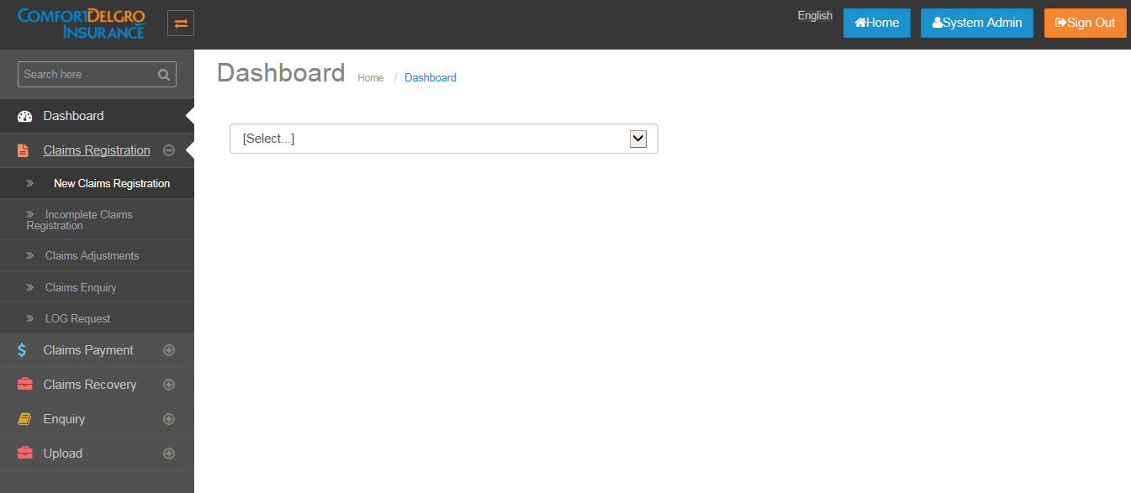

* Claim Registration module appears on left side pane of home screen.
* By Default claim Registration menu will come in expand (+) mode and user can click on “+” button to view submenu.

# New Claim Registration

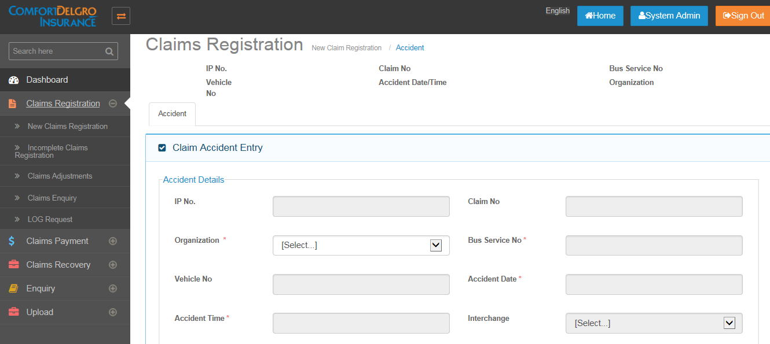

## Description

* New Claim registration will be created when user want to create manual claims ( unreported claims)
* Under New Claim registration , user can insert values in following screens:
  + Accident
  + Claims
  + Service provider
  + Notes
  + Tasks
  + Attachments
  + Diary
  + Reserve

**Note:**

In new claim registration menu, Accident screen will first show only “organization” field in editable mode and once organization is entered, all other fields will be enabled for editing. Please see below attachment:

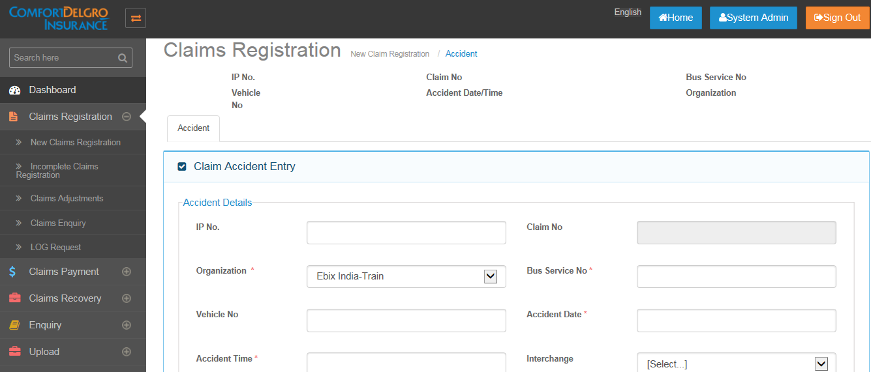

* Please find below list of tab screens accessibility information on new claim registration menu.
* No shows that that screen will neither hidden or grayed out for the menu.

|  |  |
| --- | --- |
| Accident | No |
| Claims | Hide |
| Service Provider | Hide |
| Notes | Hide |
| Tasks | Hide |
| Attachments | Hide |
| Diary | Hide |
| Reserve | Hide |
| Mandate | Hide |
| Payment | Hide |
| Recovery | Hide |
| Transaction History | Hide |

# Incomplete Claim Registration Screen

* After saving new claim registration -> accident screen, unreported claim number will be generated and claim will flow to incomplete claim search screen.

## Search screen snap shot

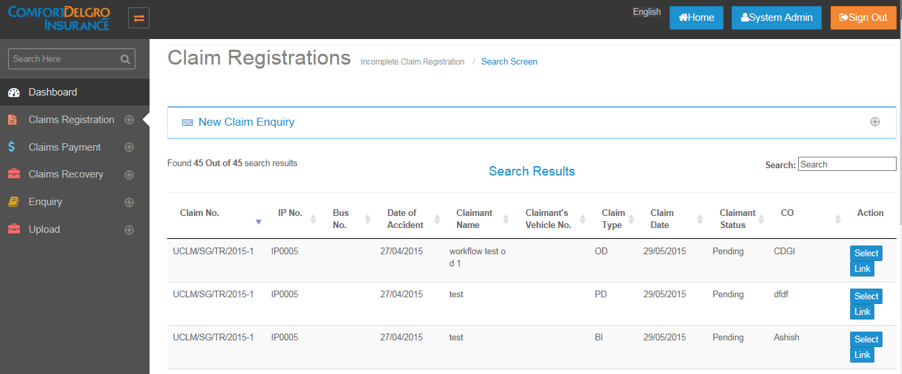

* Please find below list of tab screens accessibility information :
* “No” shows that that screen will neither hide or grayed out for the menu.

|  |  |
| --- | --- |
| Accident | No |
| Claims | Activated only when Any Own Damage = Yes, Any Property Damage / Bodily Injury = Yes else Grayed Out. Grayed Out means user can only see the Tab but clicking on it will do nothing. |
| Service Provider | Activated only when any OD, PD, BI Claims are created else Grayed Out. |
| Notes | No |
| Tasks | Activated only when any OD, PD, BI Claims are created else Grayed Out. |
| Attachments | Activated only when any OD, PD, BI Claims are created else Grayed Out. |
| Diary | No |
| Reserve | Activated only when any OD, PD, BI Claims are created else Grayed Out. |
| Mandate | Grayed Out |
| Payment | Grayed Out |
| Recovery | Grayed Out |
| Transaction History | No |

# Claim Adjustment Menu

* Once mandatory fields of claim and accident screen has been filled and user click on complete button on incomplete claim registration menu -> accident screen , record will flow to claim adjustment menu.
* This menu is primarily used for reserve adjustment and mandate request/approval.
* Please find below list of tab screens accessibility information :
* “No” shows that that screen will neither hide or grayed out for the menu and user will be able to edit on the screen.

|  |  |
| --- | --- |
| Accident | No |
| Claims | No |
| Service Provider | No |
| Notes | No |
| Tasks | No |
| Attachments | No |
| Diary | No |
| Reserve | No |
| Mandate | No |
| Payment | Grayed Out |
| Recovery | Grayed Out |
| Transaction History | **No** |

# Claim Enquiry

* All finalized claims will be appeared in claim enquiry search screen.
* User can export information in excel format after from claims enquiry menu.
* Only claimant status on claim screen will be editable and user can reopen any finalized claim.
* Please find below list of tab screens accessibility information :
* “No” shows that that screen will neither hide or grayed out for the menu and user will be able to edit on the screen.

|  |  |
| --- | --- |
| Accident | View Only – Not Editable |
| Claims | Claimant Status Field Is Editable – Shows Only Reopened Option |
| Service Provider | View Only – Not Editable |
| Notes | View Only – Not Editable |
| Tasks | View Only – Not Editable |
| Attachments | View Only – Not Editable |
| Diary | View Only – Not Editable |
| Reserve | View Only – Not Editable |
| Mandate | View Only – Not Editable |
| Payment | View Only – Not Editable |
| Recovery | View Only – Not Editable |
| Transaction History | View Only – Not Editable |

# LOG Request

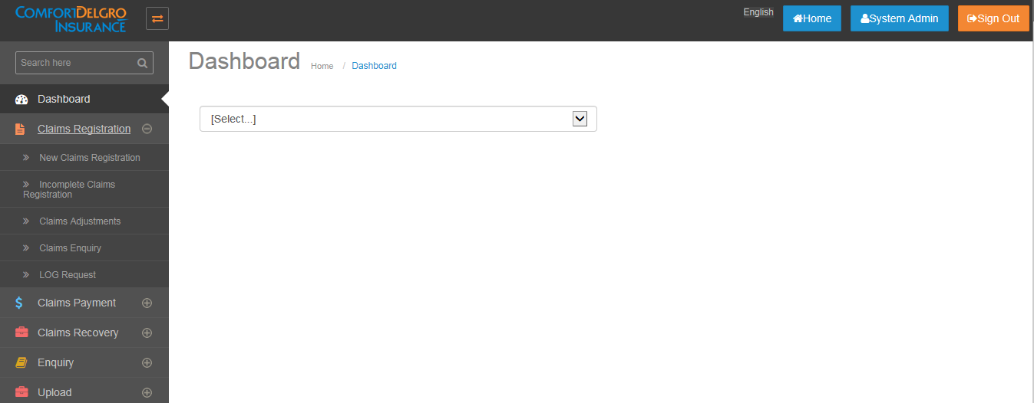

* LOG Request screen will appear in left side menu under claim registration module.
* Only when TPBI Claims is created and when there is Approved Mandate Amount for LOG Medical Expenses Field, then that Claim Number will flow to the LOG Request Screen for user to click on Create Link to create LOG Request.
* Approved Mandate Amount for LOG Medical Expenses Field will populate the LOG Amount in the LOG Request Screen and will not be editable.
* Claimant Name will populate the Name created with the TPBI Claim and not editable.
* Once User clicks on Save, LOG Reference Number will be generated and the Search Display Results will populate the LOG Reference Number and the Hospital Name

## Search screen

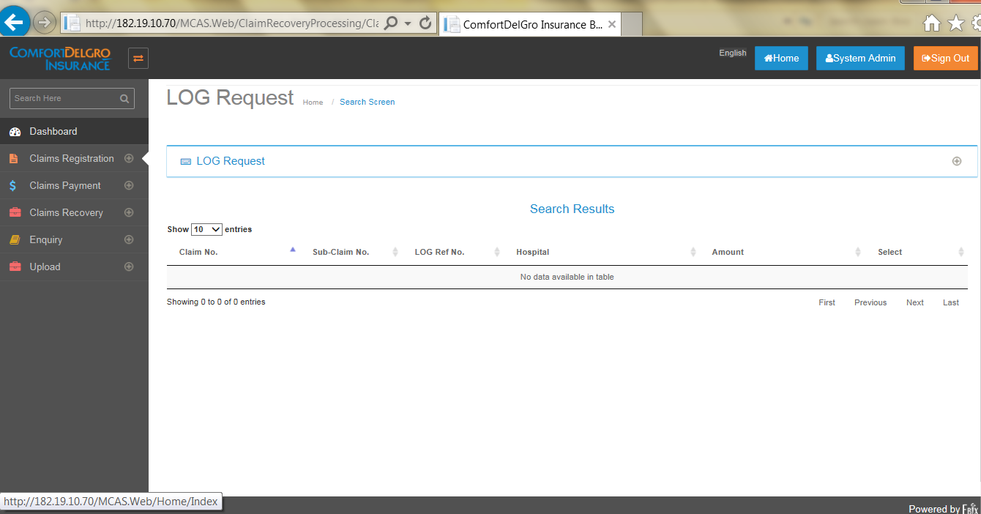

## Home screen

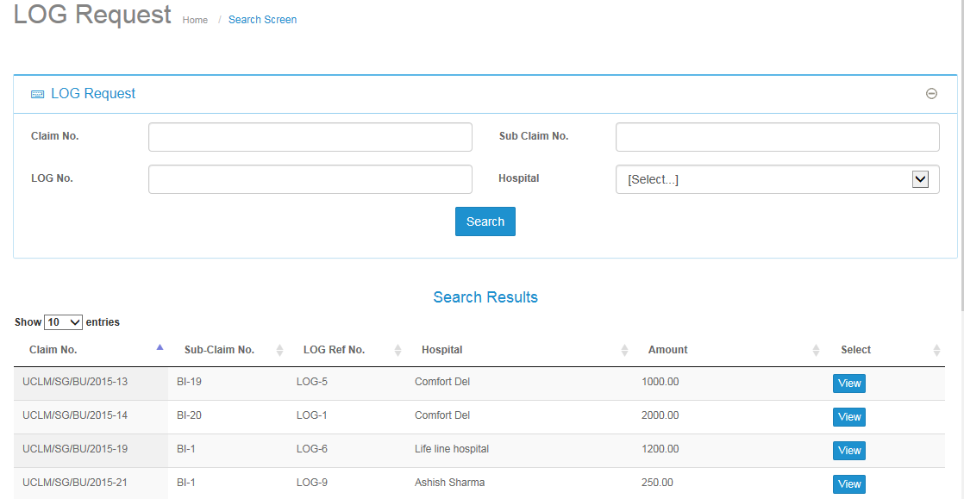

* User can see the list of LOG requests created so far in search result section.
* User can also search LOG request by filling up search criteria.
* If user clicks on View button below mentioned screen will appear.

## New LOG Request screen

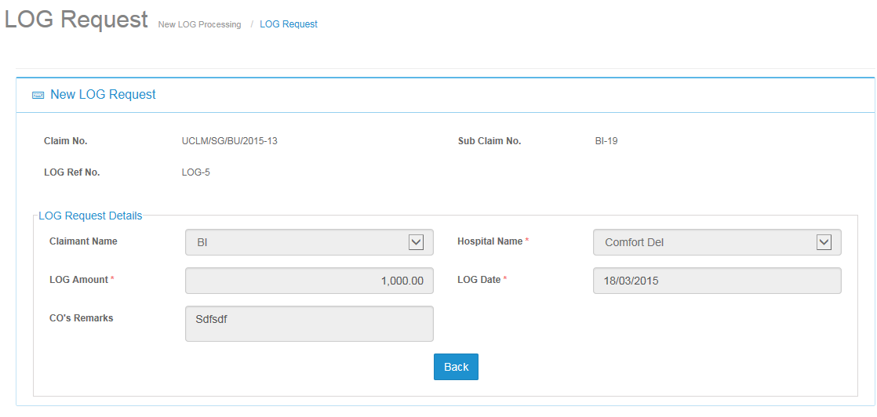

* Once User clicks on “Save” Button, LOG will be created.